**PRODUCT GET [inputProduct Method]**

**checks for @SessionAttributes**

No Session attribute named Leonardo

No Session attribute named Splinter

**Checks for “regular” Attributes**

Raphael : null

Donatello : null

**Checks for Application Attribute**

Application Name : SessionExample

**Adds @SessionAttributes & “Regular” Attributes**

Generates Form screen:

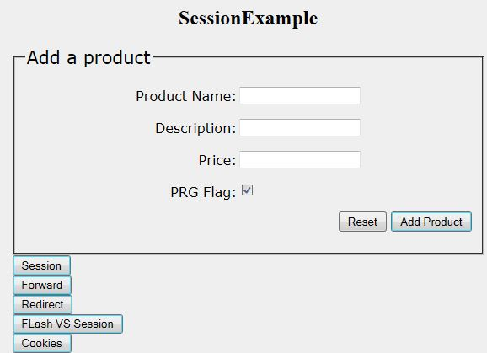

“SESSIONEXAMPLE” is the application attribute SET in the configuration file

PRG Flag – Whether or not to do FlashAttributes/PRG Pattern on POST. Also Calls status.setComplete()

**Session Button** – Demonstrates @SessionAttributes passed between controllers…

**Forward Button** – Demonstrates server side “continuity” of request attributes

ALSO, adds @SessionAttribute [Michelangelo] and REMOVES it in same method

**Redirect Button** – Demonstrates loss of request attributes on “roundtrip”

ALSO, Demo @RequestParam

**Flash VS Session Button** – Demonstrates the potential conflict between Flash Attributes AND session

Attributes

**Cookies Button** – Demonstrates the use of Cookies for state management